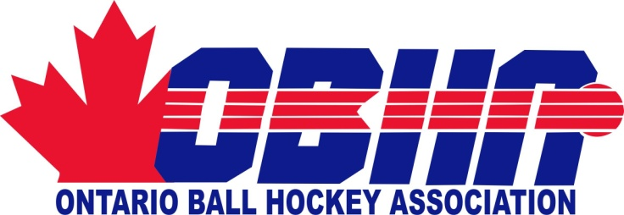 |  | 56 Pennsylvania Avenue, Unit 5  Concord, Ontario, L4K 3V9  T: 905-738-3320  www.ontarioballhockey.ca
ROWAN’S LAW/CONCUSSION CODE OF CONDUCT AND CONCUSSION AWARENESS RESOURCE ACKNOWLEDGEMENT FORM

As of July 1, 2019, every sport organization in Ontario must adhere to the Government of Ontario’s enactment of Rowan’s Law (Concussion Safety).
If you are an Ontario Ball Hockey Association (OBHA) athlete under 26 years of age, the parent of an athlete under 18, a coach, a team trainer or a game official, you need to follow the rules of Rowan’s Law, which include:
1. Review the Ontario's official Concussion Awareness Resources before registering or serving with the OBHA. Concussion Awareness Resources can be found at this website: www.Ontario.ca/concussions
- 10 and Under Concussion Awareness Resource
- 11-14 Concussion Awareness Resource
- 15 and Over Concussion Awareness Resource
2. Review the OBHA’s Concussion Code of Conduct that is provided to you found on the OBHA website at www.ontarioballhockey.ca under the Rowan’s Law Tab.
3. Confirm that you have reviewed both of these resources every year with the OBHA.
Acknowledgement of Review
By signing this form, I confirm that I have reviewed the applicable Concussion Awareness Resource at www.ontario.ca/concussions and that I have fully reviewed and commit to the Ontario Ball Hockey Association’s applicable Concussion Code of Conduct.

Name of the  Participant: | _______________________________ | Date of Birth  Of Participant: | DD/MM/YYYY  ___/____/____
For participants under 18 years of age,
Name of Parent/Guardian: ___________________________________________

Signature of the Parent/Guardian: ________________________________________________
Signature of the Participant if over the age of 18: ___________________________________
Disclaimer: In order to register/participate in the Ontario Ball Hockey Association this signed form must be submitted to the Ball Hockey Association that you are registered with.

